Pizza Sales Query Report

-- Total Revenue--

Select sum(total_price) as Total_Revenue from pizza_sales;

Result:

-- Average Order Value --

select sum(total_price)/count(distinct order_id) as Average_order_Value from pizza_sales

Results:

-- Total Pizza Sold--

select sum(quantity) as Tot_Pizza_Sold from pizza_sales

Result:

-- Average Pizza Ordered --

select cast(sum(quantity) as decimal(10,2))/

cast(count(distinct order_id)as decimal(10,2)) as Avg_Pizza_odrd from pizza_sales

Result:

--Order Trends by Days--

select Datename(DW , order_date) as Order_day, count(distinct order_id) as Total_Orders

from pizza_sales

group by Datename(DW , order_date)

Result: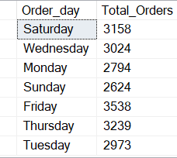

-- Monthly Trends for Total Orders --

select Datename(Month, order_date) as Monthly_orders, count(distinct order_id) as Total_order

from pizza_sales

group by Datename(MONTH,Order_date)

Result: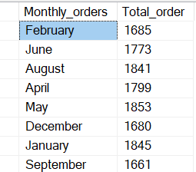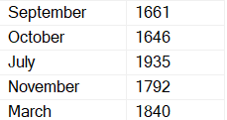

-- Sales percentage by Pizza Category--

select pizza_category, sum(total_price)*100/(select sum(total_price) from pizza_sales) as PCT_Pizza_Sales

from pizza_sales

group by pizza_category

Result: 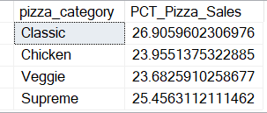

-- Percentage of Sales By Pizza size--

select

pizza_size,

round(sum(total_price)*100/(select sum(total_price) from pizza_sales),2) as PCT_pizzasize_sales

from pizza_sales

group by pizza_size

order by PCT_pizzasize_sales desc

Result: 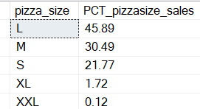

-- Top 5 Pizza by Revenue--

select top 5

pizza_name,

count(pizza_name) as Pizza_sold,

sum(total_price) as Total_Revenue

from pizza_sales

group by pizza_name

order by Total_Revenue desc

Result: 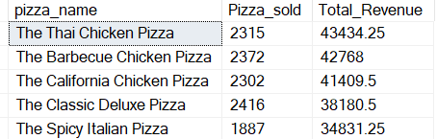

-- Top 5 Pizza Sales by Quantity--

select Top 5

sum(quantity) as Total_Quantity,

Pizza_name

from pizza_sales

group by Pizza_name

order by sum(quantity)desc

Result: 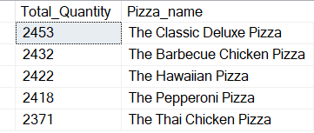

-- Top 5 Pizza Sales by Order--

select Top 5

sum(distinct order_id)as Total_Order,

Pizza_name

from pizza_sales

group by Pizza_name

order by sum(distinct order_id) desc

Result: 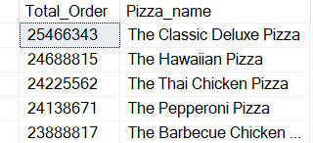

-- Bottom 5 Pizza By Revenue--

select top 5

pizza_name,

count(pizza_name) as Pizza_sold,

sum(total_price) as Total_Revenue

from pizza_sales

group by pizza_name

order by Total_Revenue asc

Result: 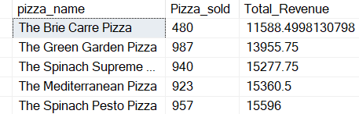

-- Bottom 5 Pizza Sales by Quantity--

select Top 5

sum(quantity) as Total_Quantity,

Pizza_name

from pizza_sales

group by Pizza_name

order by sum(quantity)asc

Result: 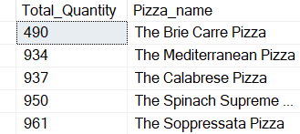

-- Bottom 5 Pizza Sales by Order--

select Top 5

sum(distinct order_id)as Total_Order,

Pizza_name

from pizza_sales

group by Pizza_name

order by sum(distinct order_id) asc

Result: 